Research Plan about Online Shopping Website

Nowadays more and more people start using online shopping website. Its convenience and popularization is undoubted. Online shopping website is a platform which provide electronic commerce that allows consumers to directly buy goods or services from a seller over the Internet using a web browser. After the payment, the buyer and seller can stay at one place. Besides, buyers use online bank service to pay to the seller’s online bank service account. The Products will be delivered to buyer’s address which relies a lot on shipping company. And relevant purchase service will be provided online.

So our team want to design an online shopping website. Before the design and development of a online shopping website, we must find some guideline and samples to ensure our website. We aim to learn some advantages we can benefit from some successful online shopping websites. Based on the study of the features and functions, we are able to make proper decisions on design and development of our own website.

Online shopping website has many common features and functions. Here some important ones.

-Commodity categorization
For users to find the product of interest, commodity categorization makes it faster.
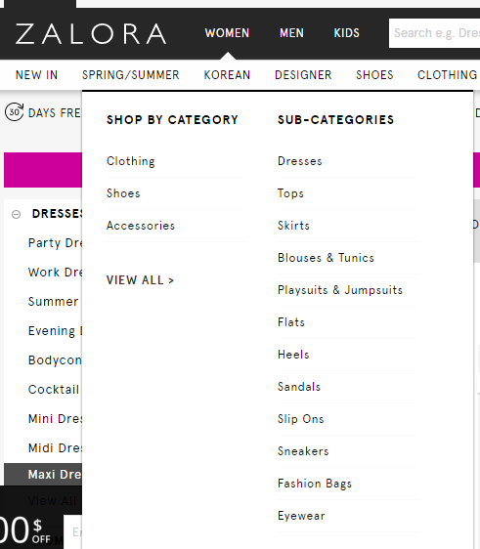
Another point is about how online websites classify their users and products. For example, Jingdong has 15 categories. In every categories, there are about 20 to 80 subcategories. How to maximize the effect of these categories is a problem. Both Jingdong’s and Taobao’s categories are in the left-hand side which is a feature we should be concerned. One reason of this feature is to match with user’s habit. People are used to reading from left to right. And how to classify a number of categories would be a challenge. The purpose of this argument is to make users to search conveniently for the products they want.

-Shopping cart
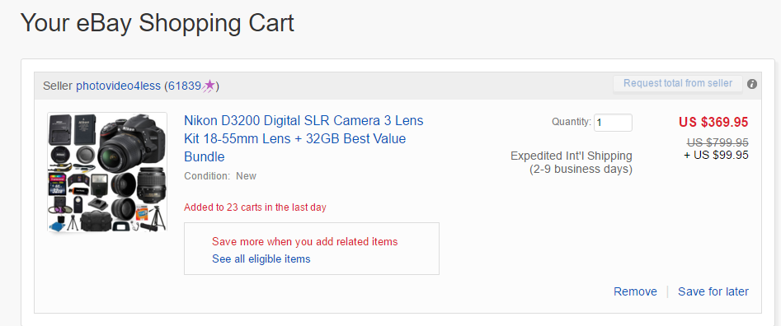
When people go shopping, they tend to look around for different product before they can make the final decision for what to buy. So, we must have a temporary storage for keeping those information.
When buyer clicks “add to cart” button of a product, the product will be preserved into shopping cart. Buyers can set the quantity of the product he want to buy and pay for all the products in shopping cart at one time. Most online shopping websites have this function.

-Transaction accuracy
Payment platform is a third-party platform which provides safe trading way in online purchasing.

Online shopping website usually has its own payment platform. Payment platform is an intermediary that guarantees the transaction security. After consumer order a product, consumer has to pay in a secure way. On the other hand, the buyer should receive the products they meant to order after payment. Usually they transact money from the online bank to the payment platform. Money won’t directly transact into seller’s account until the product arrives at consumer’s hand. Doing so can maintain the safety of transaction between the buyer and seller.

There are many different online shopping websites. Different online shopping website has different payment platform. Jingdong has Jingdong Payment.


Taobao has Alipay.


Ebay has Paypal.

They are also finance products. And the payment platform has many services which attract consumers to use the payment platform as well as online shopping website. As a result, this builds trust on consumers. Consumer experiences highly satisfactory encounters. Besides, consumer develops fierce loyalty or strong preference.

-Shipping
After a product is paid, it will be delivered to buyer’s address. Shipping ability influence user experience. Delivery speed, intact of product have impact on user’s comment of the service.

Jingdong has its own shipping department. Taobao has cooperation with many shipping companies. Different shipping companies have different delivery means and service. Sellers on the Taobao has seldom impact on shipping which many users may suffer from it. So choosing a good shipping company is a major concern of buyers.
In the shipping process of a product, when the product reach a new place, the tracking information of the product on the shipping company’s website will be updated. User can look through the tracking information anytime.

-Analysis of consumer demand
Online shopping website’s database can analyze buyer’s browsing history in order to post some products that buyers might be interested in. It’s a way to increase the sales of products on website. On the other hand, buyers may find out products they need in the posting.

-Authenticity
Users have strong wish to know the authenticity of products. And to protect the fairness of both sellers and buyers. Online shopping website have commenting function.
Users can benefit from commenting the products they have bought. For Jingdong users, after they comment they well get a virtual value called jingdou. Consumers can use jingdou for discount although it will not be too much.

It’s a brilliant way to encourage user to comment the product. Other users can look through these comments and rating even though they didn’t buy the product. Users can’t comment and rate products until they buy them. The comments can indicate the product’s fame, authenticity, specific function, detailed exterior and etc, which helps buyer to know more details about the products. As a result, this provides with a convenient way for consumers to compare the products. So even a number of sellers are selling the same products, its price will stay at a reasonable level. That can guarantee the fairness for both sellers and buyers.

These online shopping websites provide both sellers and buyers with many good features we can adopt. Based on the studies, the findings are summarized as follow:

Findings:
- Shipping system have much impact on user’s experience.
- Payment platform bring alone more convenience to buyers and sellers. More importantly, it can guarantee the safety of purchase transaction.
- Commodity categorization optimize interface of website and enhance user’s experience. Allow buyers to search for the products in a shot time.
- Shopping cart makes payment faster.
- Buyer’s comments on product shows the authenticity of product and increase fairness of trading.

